The sensitivity to polarization in stratospheric aerosol retrievals from limb scattered sunlight measurements

B. J Elash, A. E. Bourassa, L. A. Rieger, S. R. Dueck, D. A. Degenstein

**Abstract: Satellite measurements of limb scattered sunlight at visible and near infrared wavelengths have been used successfully for several years to retrieve the vertical profile of stratospheric aerosol extinction coefficient. These existing satellite measurements are of the scalar radiance, with very little knowledge or impact of the polarization state of the limb radiance, by nature of the instrument design. Recently proposed new instrument concepts for stratospheric aerosol profiling have been designed to measure the linearly polarized radiance. Yet to date, the impact of the polarized measurement on the retrievals has not been systematically studied. Here we use a fully spherical, multiple scattering radiative transfer model to perform a sensitivity study on the effects of the polarized measurement on stratospheric aerosol extinction retrievals. In this study, we simulate both the scalar and linearly polarized measurements, for a wide range of limb viewing geometries that are from encountered in typical low earth orbit and for various aerosol loading scenarios. The orientation of the linear polarization with respect to the horizon is also studied. It is found that in general, the linear polarization can be used at least as effectively as the scalar measurement. However, depending on the orbital geometry and orientation of the sun, one specific orientation of the linear polarization is favorable.**

# **1 Introduction**

Recent studies have proposed a so called global warming hiatus due to an increase in the background stratospheric sulfate aerosol layer. (Solomon et al., 2011; Haywood et al., 2014; Fyfe et al., 2013). The increase in stratospheric aerosol over the last decade is believed to be caused by a series of somewhat minor, mostly tropical volcanic eruptions (Vernier et al., 2011). Stratospheric aerosols cause a cooling effect by scattering incoming irradiance and has an important radiative effect on the climate of the planet which depends on the concentration and particle size distribution (Kiehl and Briegleb, 1993; Stocker et al., 2013).

Stratospheric aerosol distributions have been monitored on a global scale since the 1970s with satellite instruments using a variety of remote sensing techniques. The first satellite aerosol extinction profile retrievals were from limb sounding solar occultation measurements, most notably from the NASA SAGE missions (Russell and McCormick, 1989; Thomason and Taha, 2003). The solar occultation technique has provided a robust and reliable method to retrieve aerosol by directly measuring the atmospheric optical depth. However, the global sampling of occultation measurements is somewhat limited due the necessity of a sunrise or sunset and typically requires months to cover a large range of latitudes. Limb scatter measurements, such as from OSIRIS (Llewellyn et al., 2004), SCIAMACHY (Bovensmann et al., 1999), and OMPS (Rault and Loughman, 2013), have better coverage by only requiring the sunlit conditions at the tangent point, but the retrieval of aerosol is more complex requiring computationally heavy forward modelling and inversion compared to occultation. It is worthwhile to note that the combination of the SAGE II and OSIRIS datasets have recently been used to successfully create a single long term merged time series depicting the evolution of the stratospheric aerosol layer (Rieger et al., 2015).

OSIRIS, SCIAMACHY, and OMPS measure the spectral radiance of the scattered sunlight from the limb and use inversion techniques to determine aerosol extinction profiles (Bourassa et al., 2012b; Ernst et al., 2012, Rault and Loughman, 2013). It should be noted that currently none of these retrievals account for any polarization sensitivity in their respective measurements. Future instruments with the capability to measure aerosol from the limb have been proposed including the Belgium instrument Atmospheric Limb Tracker for the Investigation of the Upcoming Stratosphere (ALTIUS) (Dekemper et al., 2012) and the Aerosol Limb Imager (ALI), a Canadian endeavour (Elash et al., 2016). Both instruments use acousto-optic tunable filters to select the measured wavelength but can only measure one orientation of the linearly polarized signal, whereas previous limb scatter instruments have used scalar measurements to perform the inversion. Although it has been previously shown that the retrieval of stratospheric aerosol extinction profiles from polarized scattered sunlight measurements are possible (Elash et al., 2016; McLinden et al., 1999), the impacts of the polarized measurement have not been systematically studied. In this work we perform an analysis on simulated polarized measurements and determine which linear polarization and viewing geometries have the largest sensitivities to aerosol, and how the polarized measurements affect the accuracy and precision of the retrieved aerosol product.

# **2 Background and Forward Model**

In order to compare the effect of polarization on the sensitivity to aerosol, one must be able to accurately model polarized radiance. Additionally, a large number of scenarios are required with different atmospheric states and geometries to fully probe the solution space. In this section, the SASKTRAN-HR model used for the analysis with be discussed as well as aerosol scenarios used for the study.

## 2.1 Polarized scattered sunlight and stratospheric aerosols

The polarization for electromagnetic waves can be fully defined by the Stokes vector. The Stokes vector is given by a column matrix

$$I= \left[\begin{matrix}I \\ Q \\ U \\ V\end{matrix}\right] \left(1\right)$$

where the terms of the Stokes vector are the total radiance, the horizontal polarization, the +45o diagonal polarization, and the counter clockwise polarization from top to bottom. Using a reference frame where the x-axis is defined to be the horizontal polarization leads to the following definition for the Stokes parameters

$$\begin{matrix}I= <E_{x}>^{2}+<E_{y}>^{2} \\ Q= <E_{x}>^{2}-<E_{y}>^{2} \\ U=2Re\left(<E_{x}><E_{y}^{*}>\right) \\ V= -2Im\left(<E_{x}><E_{y}^{*}>\right).\end{matrix}(2)$$

To model the scattering for an incident ray propagating in a given direction the ray undergoes a rotation into the Stokes reference frame then is multiplied by the phase matrix. After the multiplication the result is rotated back into the ray’s initial coordinate system through the following

$$I^{sca}= L\left(θ_{2}\right)PL\left(θ_{1}\right)I^{inc}. (3)$$

The scattered and incoming radiances are 4 by 1 matrices given by $I^{sca}$ and $I^{inc}$, the rotation matrices are given by $L$ and rotates the incoming ray and scattered ray by rotations angles $θ_{1}$ and $θ_{2}$. The phase matrix is a 4 by 4 represented by . The phase matrix is the effect on how an incoming ray is scattered and into what polarization state.

For this work, two primary scattering interactions induce and/or modify the polarization state of the light propagating in the atmosphere. These are scattering by the molecular air density and by stratospheric sulfate aerosols. The molecular atmosphere interaction is referred to as Rayleigh scattering, and has a phase matrix that is determined from the Rayleigh-Gains approximation (Mishchenko et al., 2002) given by

$$P_{ray}=\frac{3}{4}\left[\begin{matrix}1+\cos^{2}{Θ} & -\sin^{2}{Θ} & 0 & 0 \\ -\sin^{2}{Θ} & 1+\cos^{2}{Θ} & 0 & 0 \\ 0 & 0 & 2cosΘ & 0 \\ 0 & 0 & 0 & 2cosΘ\end{matrix}\right] (4)$$

where $Θ$ is the scattering angle.

For randomly orientated particles only six elements of the phase matrix are required (van de Hulst, 1957) which are the following

$$P=\left[\begin{matrix}P_{11}(Θ) & P_{12}(Θ) & 0 & 0 \\ P_{12}(Θ) & P_{22}(Θ) & 0 & 0 \\ 0 & 0 & P_{33}(Θ) & P_{34}(Θ) \\ 0 & 0 & -P_{34}(Θ) & P_{44}(Θ)\end{matrix}\right] (5)$$

Additionally, for spherical particles like stratospheric aerosol only four unique terms are needed since $P_{11}=P_{22}$ and $P_{33}=P_{44}$. Aerosol scattering is modeled by Mie theory (Mie, 1908), for which several standard codes have been developed to calculate scattering cross sections and phase matrices based on the particle size distribution and index of refraction (e.g. Wiscombe, 1980). A full derivation can be found in van de Hulst (1957).

The basic polarization state of the scattered light in the earth’s atmosphere can be understood by first considering a single scattering event of the randomly polarized incoming sunlight in a molecular atmosphere. It can be easily seen from the form of the Rayleigh phase matrix (Eq. (4)) that a single scattering event causes the sky to develop a distinct polarization at a scattering angle of 90 degrees from the incoming solar beam. The scattered sunlight is linearly polarized in the horizontal orientation, which is parallel to the horizon and gradually becomes fully randomly polarized at scattering angles of 0 and 180 degrees, i.e. forward and backscatter respectively. If multiple scattering events are taken into account, the degree of polarization is decreased at 90 degrees scattering angle, and also does not become completely randomly polarized at forward and backscatter. Simulations with the forward model described below show that at 90 degrees scattering angle, the degree of linear polarization is approximately 95%. Furthermore, this polarized effect is strongest at longer wavelengths (1500 nm) and decreases, on average by 10%, as the wavelength become shorter (500 nm). As the scattering angle decreases or increases from 90 degrees, the degree of linear polarization decreases to approximately 20% for backscatter and 30% for a scattering angle of 45 degrees.

For an atmosphere that contains both the molecular air density as well as a typical background state burden of stratospheric sulfate aerosol, both Rayleigh and Mie scattering occur in a weighted fraction according to the optical depth of air and aerosol. Compared to the pure Rayleigh scattering case, a decrease in the degree of horizontal polarization occurs for wavelengths from 500 to 1250 nm, and interestingly from 1250 to 1500 nm the opposite occurs. This is due to the changing fraction of scattering from air and aerosol as the Rayleigh scattering cross section falls off much more quickly with wavelength than the aerosol cross section. These changes are present for all scattering angles. The observed change in linear polarization is approximately 7% for the typical background state, but it varies depending on aerosol loading and microphysical parameters of the aerosol.

## 2.2 SASKTRAN-HR model

The radiative transfer model SASKTRAN-HR (High-spatial Resolution) (Bourassa et al., 2007; Zawada et al., 2015) was used in this study. The SASTRAN-HR provides flexible user specified atmospheric species and concentrations and uses a fully 3D spherical geometry to solve the radiative transfer equation using a successive orders of scattering technique. SASKTRAN-HR also has the capability to calculate the polarized, or vector, radiances exactly for the first three scattering events, which contribute to most of the signal in limb scatter. The polarization states of higher orders of scattering are approximated with minimal impact on the final solution (Dueck et al., 2016). All calculations performed with SASKTRAN-HR in this study assume randomly polarized sunlight and Rayleigh and Mie scattering events only to model the interaction with the molecular air density and stratospheric aerosol, respectively. Scattering events from the Earth’s surface are assumed to be Lambertian and fully depolarizing.

## 2.3 Model Scenarios

The impact of a polarized measurement on stratospheric aerosol retrievals from limb scattered sunlight is systematically studied by exploring a set of distinct cases that attempt to cover the expected range of aerosol parameters, including both particle size and concentration (or extinction) profiles, and viewing geometries. Even in the case of scalar radiance measurements, the geometry of the measurement can have a substantial effect on the sensitivity of the measurement to aerosol due to asymmetry of the Mie scattering phase function. (Rieger et al., 2015). This includes a strong preference for aerosol scattering in the forward direction resulting in a weaker relative aerosol signal in the backscatter direction. To probe a large portion of this parameter space, a series of scenarios were developed.

To probe the aerosol space, two extinction coefficient profiles and four particle size distributions were used. The two extinction profiles correspond to a background aerosol case, typical of the volcanically quiet period of the early 2000’s (Deshler et al., 2003), and a volcanically enhanced case which was taken from OSIRIS measurements two months after the Nabro eruption in 2012. Both profiles are shown in Figure 1. The four particle size distributions were also chosen to represent typical background and volcanically enhanced cases. The background cases are a single mode lognormal distribution with somewhat different, but typically observed, size parameters. A multi-modal log-normal particle size distribution was used for the volcanically enhanced cases, with one fine mode and one coarse mode each comprising an equal fraction of the total extinction. All of the parameters of the size distributions are detailed in Table 1. These selected distributions are based on in-situ balloon particle counter measurements from Laramie, Wyoming (Deshler et al., 2003).

To probe the entire geometry, a range of Solar Zenith Angles (SZAs) and Solar Scattering Angles (SSA) were selected. The ranges were selected to give representative selections of the possible geometries of a limb scatter instrument in low earth orbit. The selected values for SZA are 15 o, 45 o, and 75o and for SSA of 30o, 60o, 90o, 120o, 150o, and 180o. The modelling was performed at wavelengths of 500, 750, 1000, 1250, 1500 nm, which approximately cover for the range of wavelengths commonly used by aerosol retrievals from limb instruments. For example, OSIRIS and SCHIAMACHY aerosol products use the ratio of 750 nm to 470 nm for the aerosol retrieval (Bourassa et al., 2012b; Ernst et al., 2012) and near infrared wavelengths have been shown to provide particle size information from limb scatter measurements (Rieger et al., 2014) and so the 1000-1500 nm wavelength range was also important to include in this study. The other important input parameter is the albedo of the Earth’s surface and for this study we use both values of 0 and 1 in order to cover the full range of potential impact.

## 2.4 Methodology

For the purposes of this study, we have assumed an instrument capable of measuring only the linear polarization with either a vertical or horizontal orientation. This was chosen since upcoming instruments like ALTIUS (Dekemper et al. 2012) and ALI (Elash et al., 2016) use an acousto-optic tunable filter for a spectral filter and these instrument by nature only measure one orientation of linear polarization. We wanted to be able to answer the question: if only one linear polarization can be observed, which orientation is the best option, and further, how do the polarized measurements compare, in terms of aerosol retrievals, to the sensitivity of an instrument that measures scalar radiance?

The polarization states used here are defined as the following: the linearly polarized radiance aligned with the horizon is referred to as the horizontal polarization, and the linearly polarized radiance that is perpendicular to the horizon is referred to as the vertical polarization. We also use the total, or scalar, radiance as the reference case. Using the Stokes parameters, the scalar radiance is defined as $I$, the horizontal polarization is given by $0.5\left(I+Q\right)$ and the vertical polarization is given by $0.5(I-Q)$.

The study looks at the problem in three sections. How does the fraction of the limb scatter signal, scalar and polarized, that is due to aerosol vary for a range of geometries and aerosol profiles? How does the polarized measurement affect the ability to retrieve aerosol using an assumed particle size distribution, as is the case in the OSIRIS and SCIAMACHY retrieval algorithms? And finally, how does the polarized measurement effect the uncertainty estimate of the retrieved profile? Within this section the methodology for each question will be described.

First, the modeled radiance will be compared for a series of geometries, wavelengths, and altitudes to determine the approximate fraction of the signal that is due to aerosol. The model is run with a nominal atmosphere that consists of molecular air, ozone, and NO2 which is kept constant, and with a variable altitude and albedo. The aerosol fraction was determined by calculating the nominal radiance without aerosol in the model, $I_{nom}$, and the total radiance including the aerosol, $I_{tot}$, and using the difference between the total radiance and nominal radiance to find the approximate fraction of the signal due to aerosol. Thus to determine the percent of the signal that is attributed, the following formulation is used

$$Percent_{aerosol}=\frac{I_{tot}-I_{nom}}{I_{tot}}*100\%. (6)$$

Although due to non-linearities from multiple scattering, this is not strictly true; however at most stratospheric tangent altitudes, the wavelengths under study are quite optically thin and this simple percent difference will provide an intuitive approximation of the fraction of the signal due to aerosol. Furthermore, polarized measurements of radiance will be smaller in magnitude than the scalar counterpart and the percent loss will be used to estimate increases in instrument sensitivity needed to compensate.

To determine the effect of polarization on the retrieval, a retrieval method is used similar to aerosol extinction retrieval by Bourassa et al. (2012b). A minor change to the algorithm is made where the measurement vector here is not normalized by a shorter wavelength since work by Rieger et al. (2014) has shown this decreases sensitivity to particle size distributions. Although it is advantageous to limit sensitivity to particle size, it is advantageous to know what the worst case scenario would be to know the possible limitations of future technology, especially given that not all instruments may cover the required spectral range. For the retrievals, a simulated measurement radiance profile is calculated using the SASKTRAN-HR model with nominal ozone and NO2 profiles for each of the aerosol parameter scenarios listed in section 2.2. The simulated measurements are then used to retrieve aerosol extinction profiles using the Bourassa et al., 2012b technique for all three polarization states. Additionally, a retrieval will be performed with the scalar SASKTRAN-HR model to see if there is a large difference between using the scalar and the polarized model to retrieve aerosol profiles from a scalar measurement. For each aerosol retrieval, the ozone, NO2, and albedo are set the same values used in the simulation of the measurement, except the aerosol particle size is fixed as a single mode log-normal with 0.08 µm mode radius and mode width of 1.6. The assumption of a fixed particle size distribution is very common in current limb scatter retrievals and this is used to explore how the polarized measurements are sensitive to particle size distributions and if the uncertainty in this assumption greatly affects the retrieved extinction.

Lastly, an error analysis is performed in order to check the precision of the retrieved aerosol profile. The method used for this analysis is one presented by Bourassa et al. (2012a) in which it is assumed that the Jacobian, $K$, times the Gain matrix, $G,$ is approximately equal to the identity matrix so

$$G≅K^{-1}. (7)$$

With an assumed covariance on the aerosol retrieval, $S_{ϵ}$, the covariance on the aerosol profiles can be found by

$$S_{aero}=GS_{ϵ }G^{T}. (8)$$

Finally, the square root of the diagonal of the aerosol covariance is taken as the final error profile. Using the results from all the cases, statistics are used to determine any trends in the obtained precision across the input parameters..

# 3 Analysis

## 3.1 Aerosol Sensitivity

First, contribution to the total limb radiance from aerosol was analyzed across wavelength and over a series of tangent altitudes for the background aerosol profile and the particle size distribution 1, given in Table 1. Figure 2 shows the difference between the fraction of the limb radiance due to aerosol for a linearly polarized measurement and the fraction due to aerosol for the scalar measurement. Note that the fraction of the signal due to aerosol increases as wavelengths become longer as expected due to the rapidly decreasing Rayleigh cross section. However, the fraction of the signal due to aerosol increases in the vertical polarization compared to the scalar case whereas the horizontal polarization has less sensitivity to aerosol.

A similar analysis was performed for the range of viewing geometries at a range of tangent altitudes to assess the change in aerosol signal strength. Figure 3 shows the fraction of aerosol signal for 15 km tangent altitude, with the background aerosol profile and an albedo of zero. A sharp difference is noted between the forward and backward scattering geometries. The scalar and horizontal polarization cases follow a similar dependence, with the strongest aerosol signal from long wavelengths in the forward scatter direction. For the vertical polarization, we see that it has a strong aerosol signal contribution for all forward scattering directions, especially at visible wavelengths in comparison to the scalar and horizontal polarization cases. For backward scattering, slightly less aerosol signal is observed, but the shape is similar to the scalar and horizontal cases. With the vertical polarization, it should be noted that modeling the radiance at a SSA of 90o is very sensitive to particle size distribution due to the low radiance signal, which may make this geometry difficult to perform accurate retrievals. We tested the full range of SZAs and found that the SZA only effects the fraction of the signal due to aerosol by less than 0.5% and is not an important consideration.

For the cases tested above, the sensitivity of the limb radiance to aerosol for the horizontally polarized and scalar cases is approximately the same, and the vertical polarization has better sensitivity in the forward scattering case. However, only measuring a linear polarization results in a loss of overall signal. In Figure 4, the ratio of the total polarized radiance over the total scalar radiance is shown for a SZA of 45o and SSA of 60o with a background aerosol profile. Measuring the horizontal polarization would result in only observing approximately 58% of the signal for shorter wavelengths compared to the scalar case, and at longer wavelengths this increases but only to approximately 66%. For the back scatter case, the percentage of the lost signal increases slightly to 74% at short wavelength and 80% at long wavelengths. This loss of signal, on average about 30%, would need to be accounted for by a corresponding increase in instrument sensitivity to maintain an equivalent signal to noise ratio in the measurement. For the vertical polarizations, however the increased aerosol fractional signal in the forward scatter case is met with a loss in overall signal of up to 70% compared to the scalar case and for the backscatter case a decrease of up to 85% is observed. This is a significant loss of signal that will essentially close to double the exposure time. Depending on the expected exposure times for an optical instrument, this may lead to a situation where the increases results in unacceptable times despite the increase in aerosol sensitivity.

Lastly, as the amount of aerosol in the atmosphere increases, obviously so does the percent of the signal which is attributed to aerosol. Eventually, an increase in aerosol will result in little change to the aerosol signal which limits the highest aerosol concentration that can be retrieved from a measurement. In Figure 5, the background aerosol profile is successively scaled to higher values and the fraction of signal due to aerosol is calculated for each scaled valued. Again these simulations are performed with a SZA of 45o and SSA of 60o and with an albedo of zero. In all cases, the rate of increase of aerosol signal increases substantially until approximately 90% of the radiance signal is from aerosol after which the rate of increase slows considerably. We define a saturation point that corresponds to a 0.1% increase in aerosol signal for a 0.1 increase of scale factor. For scalar and horizontal cases, saturation first occurs at 25 km when the background aerosol layer is scaled by 9.4. For the vertical polarization, which had higher sensitivity to aerosol in the forward scatter geometry, we see a cap of aerosol sensitivity at 4.4 times the background aerosol layer. For large volcanic eruptions this would limit the aerosol concentration profiles that could be retrieved from limb scatter instrument.

The vertical polarization yields significantly more aerosol signal in the forward scattering case when compared to the horizontal polarization. However, this increase in aerosol signal would result in exposure times that would be 70-85% longer than the horizontal polarization and would not be as effective as measuring aerosol during large volcanic eruptions.

## 3.2 Retrievals

Retrievals were performed for all of the wavelengths listed in section 2.2, however due to similarities between the retrievals of different wavelengths only the 750 nm wavelength will be focused on with comments on the other wavelengths necessary when deviations from the 750 nm case occur.

Retrievals with current limb scatter instruments use a scalar radiative transfer model but accounting for the vector component alters the overall scalar radiance. A brief study was performed to determine if using a scalar model for these retrievals instead of a vector model would result in biases in the retrieved aerosol profiles. For the scalar case, the aerosol retrieval was performed with both the scalar and vector SASKTRAN-HR model. A comparison between the retrieved extinctions for the scalar and vector model were performed using a percentage difference in the form

$$Percent Difference=\frac{k_{vector}-k_{scaler}}{k_{vector}}*100\%. (9)$$

Across all wavelengths, the mean percent difference is less than 2% from 15 to 37 km. However, at shorter wavelengths, for example 750 nm shown in Figure 6, a few outliers occur where the difference between the retrievals is greater than 7%. All of these retrievals occur in the backscatter condition where the SSA is greater than 90o. The reason for this discrepancy is not known, and may be due to changes in the scalar radiance due to polarization interactions from a large contribution of multiply scattered light, but further investigation is required. However, overall the differences between the retrievals using the scalar and vector models are negligible and any form of discrepancy vanished for wavelengths past 1000 nm. Since the use of the vector model can increase calculation times by a factor of two for the retrievals, it is beneficial to be able to use the scalar model for scalar radiance retrievals and can be performed for most cases.

Aerosol profiles were retrieved using an assumed particle size distribution, in this case a log-normal with a mode radius and width of 0.08 µm and 1.6 respectively, which was different than the true state. For the three tested polarization states, aerosol profiles were retrieved and separated by particle size distributions and compared against the true extinction state. The 750 nm aerosol comparisons separated by polarizations states and particle size distributions can be seen in Figure 7. It should be noted that geometries with SSA of 90o have been removed for the vertical polarization due to the weak phase function that is strongly dependant on the particle size distribution. This results in a large bias in the retrieved aerosol profile. However, using a geometry with a SSA of 85o or 95o almost eliminates the bias seen at the 90o scattering angle and it is completely eliminated once the scattering angle is less than 80o or greater than 100o.

Each of the four size distributions were used to simulate the measurements for the retrieval in order to test for any persistent biases in the various polarization cases. Recall that in all cases, the retrieval assumes a constant size single mode size distribution that does not match any of the four size distributions used to simulate the measurements. For particle size distribution one (see Table 1), retrieved aerosol extinction profiles are too large. For scalar, horizontal, and vertical polarizations had mean offsets of -9-13%, -12-17%, and -6-8% respectively from 17 to 35 km. Particle size distribution two shows a different mean offset, larger, and a higher variance is observed. The mean offset for distribution two are -20-28%, -24-31%, and -12-16% for the same polarizations from 17 to 35 km. For distributions three and four, similar variances are noted between the similar fine modes but the aerosol extinction retrieved is now much smaller than that true extinction state for all three polarizations. For distributions three and four, the mean offsets were 42-44%, 40-43%, and 45-46% and 26-33%, 22-29%, and 38-42% respectively for the same polarization ordering. Furthermore, as wavelength increases an approximately 3-5% increase in offset is observed for the retrieved aerosol profiles for each polarization. Current satellite instruments only agree to each other within 20-30% and using the above trends, accurate aerosol retrievals could be obtained for atmospheric states where only a fine mode exists. However, when a coarse mode is present in the true state, the retrieval significantly underestimates the amount of aerosol in the atmosphere. It should be noted that horizontal polarization retrieves slightly higher extinction values compared to the vertical polarization, on average 8.5% higher. Resulting in a horizontal retrieval that is closer to the true state but still too small by 20-40%. Volcanic eruptions are the main cause for a perturbation in the size distribution and this would lead to an underestimation of aerosol extinction after a significant eruption which can miss a noticeable climate forcing effect.

## 3.3 Precision analysis

Using SASKTRAN-HR, the Jacobians for all the retrieved aerosol profiles were calculated and inverted to determine the gain matrices which were used as shown in in Eq. 8 to determine the retrieval precision. It should be noted that not all of the Jacobians were stable enough to be inverted due to negative sensitivity of the lower tangent altitudes(Bourassa et al., 2007). This caused these cases to be removed from the data set. Unfortunately, this resulted in a large portion of the SSA 30o cases not to invert properly and left too few for accurate statistics and were removed. Overall, these led to a loss of 9% of all of the retrieved scans for the precision analysis.

A value of 1% was chosen for uncertainty in the measurement vector which is similar to the measurement uncertainty of the OSIRIS instrument at the aerosol retrieval wavelengths and tangent altitudes. The same uncertainty was selected no matter the polarization or geometry. This allows for the determination of the absolute change in precision for an instrument with the same measurement uncertainty no matter the polarization state measured. The diagonal values of the covariance matrix, $S_{ϵ}$, were 0.2% since they consist of the tangent altitude of the measurement and the reference altitude. The cross terms of the covariance matrix were 0.1% to represent the error in the normalization altitude. For each parameter listed in section 2.2 an uncertainty of the retrieved radiance was determined. This uncertainty, stated as a percent error, was used to determine the standard deviation and mean for each polarization and input parameter. With the statistics trends were determined for each polarization and parameter to determine if there was a large effect on the overall precision depending on the test parameters. However, the 500 nm wavelength resulted in precision estimates that were large and noisy. This lead to forming a bias in the results for the tested input parameters and was removed when doing the analysis. The remaining profiles were used to determine the percent error at each altitude and each linear polarization was compared to the scalar base case. The analysis was performed for the SSA, SZA, albedo, extinction type, fine mode type, percentage of coarse mode, and wavelength.

Two primary results were noted. First, the vertical polarization shows a an improvement in uncertainty of on average 5-10% for forward scattering cases across altitudes from 15 to 29 km that decreases as altitude increases. For backscatter scattering cases the linear polarizations yield the same percent error as the scalar case with a maximum relative percent difference of 2%. The other major note is the change of relative error with wavelength. At 750 nm the vertical polarization sees a 30% relative improvement over the base case at 16 km and gradually decreases to a 20% improvement at 28 km. For 1000 and 1250 nm the vertical polarizations and scalar once again have very similar present errors and at 1500 nm about a 5% worse relative error is seen at the lower altitudes but reaches par with the scalar case at approximately 20 km. For the horizontal case the same magnitude but opposite effects occurs for the precision. The other parameters tested (i.e. albedo, SZA, etc.) do not show a significance difference between the different polarizations and do not appear to have a large effect on the precision of the profiles.

As a final note the sensitivities of aerosol signal noted in section 3.1 was not accounted for in this analysis which in reality would alter the precision for an identical instrument measuring opposite polarizations. If we assume the instrument is calibrated such that the exposure time is set to measure the same quantity of radiance no matter the polarization then it can be determined how this would affect the precision estimate. Since the error in the measurement vector is dependent on the aerosol signal a smaller contribution of signal from aerosol would result in a larger uncertainty in the retrieved profile. This would result in the highest precision measurements from a vertically polarized instrument since the increase in aerosol signal is larger than the horizontal polarization. The precision increase would be at most a couple of percent better than the horizontally polarized case. However, if it is assumed that a constant exposure time is selected no matter the polarization, the increase in overall radiance from the horizontal polarization would result in a higher precision measurement compared to the vertical case. However, in this scenario the horizontal polarization would have a percent error on the aerosol profile of approximately half compared to the vertical polarization which would vary depending on the aerosol extinction profile and the viewing geometry.

# **4. Conclusions**

Overall choice for a polarized instrument that can only measure one polarization focused at retrieving high quality aerosol products is not a simple answer and depends on several parameters. The overall best situation would be an instrument that measures forward scattered light with vertical polarization with compensated exposure times. Recall that the vertical polarization is defined as the polarization normal to the horizon. In this orientation, the radiance measurement has good sensitivity to aerosol across all altitudes greater than 13 km. However, the increased sensitivity, especially at the shorter wavelengths, falls off quite rapidly once a SSA of 90o is surpassed. This instrument would also yield the best precision possible but it has two disadvantages. First, assuming a particle size distribution scattering angles close to 90o contain a bias in the retrieved aerosol extinction. Second, a large loss of the overall signal occurs from measuring the vertical polarization, up to 70% for forward scatter which would increase exposure times or if not accounted for decrease precision. Depending on instrument specifications, the required increase in exposure time may result in unacceptably high values.

If more signal is required or the orbit will result in a high percent of measures around a SSA of 90o, the horizontal polarization should be used. However, the preference would be for forward scatter at the longer wavelengths since a loss of aerosol signal occurs at shorter wavelengths. This would result in the highest possible aerosol signal in the radiance. Furthermore, a maximum of loss of signal would only be 42% for forward scatter which is considerably better than the vertical polarized case.

As a final note, the agreement between the scalar and vector SASKTRAN-HR model are generally within 2% of each other for the aerosol retrievals. It is promising that the inclusion of polarization in the model does not cause a large change to the retrieved profiles since the use of the vector model would result in an approximate doubling in processing time.

# Acknowledgements

NSERC?

# References

Bourassa, A. E., D. A. Degenstein, R. L. Gattinger, and E. J. Llewellyn (2007), Stratospheric aerosol retrieval with optical spectrograph and infrared imaging system limb scatter measurements, Journal of Geophysical Research, 112, D10217, doi:10.1029/2006JD008079.

Bourassa, A. E., C. A. McLinden, A. F. Bathgate, B. J. Elash, and D. A. Degenstein (2012a), Precision estimate for Odin-OSIRIS limb scatter retrievals, Journal of Geophysical Research: Atmospheres, 117, D04303, doi:10.1029/2011JD016976.

Bourassa, A. E., L. A. Rieger, N. D. Lloyd, and D. A. Degenstein (2012b), Odin-OSIRIS stratospheric aerosol data product and SAGE III intercomparison, Atmospheric Chemistry & Physics, 12, 605-614, doi:10.5194/acp-12-605-2012.

Bovensmann, H., J. Burrows, M. Buchwitz, J. Frerick, S. Noël, V. Rozanov, K. Chance, and A. Goede (1999), SCIAMACHY: Mission objectives and measurement modes, Journal of the Atmospheric Sciences, 56, 127-150.

Dekemper, E., N. Loodts, B. V. Opstal, J. Maes, F. Vanhellemont, N. Mateshvili, G. Franssens, D. Pieroux, C. Bingen, C. Robert, L. D. Vos, L. Aballea, and D. Fussen (2012), Tunable acousto-optic spectral imager for atmospheric composition measurements in the visible spectral domain, Applied Optics, 51, 6259-6267, doi:10.1364/AO.51.006259.

Dueck, S., A. E., Bourassa, and D. A. Degenstein (2015), SASKTRAN-HR Polarization Module, In Preparations.

Deshler, T., M. Hervig, D. Hofmann, J. Rosen, and J. Liley (2003), Thirty years of in situ stratospheric aerosol size distribution measurements from Laramie, Wyoming (41 N), using balloon-borne instruments, Journal of Geophysical Research: Atmospheres (1984-2012), 108.

Elash, B. J., A. E. Bourassa, P. R. Loewen, N. D. Lloyd, and D. A. Degenstein (2015), The Aerosol Limb Imager: Acousto-Optic Imaging of Limb Scattered Sunlight for Stratospheric Aerosol Profiling, Atmospheric Measurements and Techniques, In Procedings

Ernst, F., C. von Savigny, A. Rozanov, V. Rozanov, K.-U. Eichmann, L. A. Brinkho, H. Bovensmann, and J. P. Burrows (2012), Global stratospheric aerosol extinction profile retrievals from SCIAMACHY limb-scatter observations, Atmos. Meas. Tech., 5, 5993-6035, doi:10.5194/amtd-5-5993-2012.

Fyfe, J. C., N. P. Gillett, and F. W. Zwiers (2013), Overestimated global warming over the past 20 years, Nature Climate Change, 3, 767-769.

Haywood, J. M., A. Jones, and G. S. Jones (2014), The impact of volcanic eruptions in the period 2000-2013 on global mean temperature trends evaluated in the HadGEM2-ES climate model, Atmospheric Science Letters, 15, 92-96, doi:10.1002/asl2.471.

Kiehl, J. T., and B. P. Briegleb (1993), The relative roles of sulfate aerosols and greenhouse gases in climate forcing, Science, 260, 311-314, doi:10.1126/science.260.5106.311.

Llewellyn, E., N. D. Lloyd, D. A. Degenstein, R. L. Gattinger, S. V. Petelina, A. E. Bourassa,J. T. Wiensz, E. V. Ivanov, I. C. McDade, B. H. Solheim, J. C. McConnell, C. S. Haley,C. von Savigny, C. E. Sioris, C. A. McLinden, E. Grifoen, J. Kaminski, W. F. J. Evans, E. Puckrin, K. Strong, V. Wehrle, R. H. Hum, D. J. W. Kendall, J. Matsushita, D. P. Murtagh, S. Brohede, J. Stegman, G. Witt, G. Barnes, W. F. Payne, L. Piche, K. Smith, G. Warshaw, D. L. Deslauniers, P. Marchand, E. H. Richardson, R. A. King, I. Wevers, W. McCreath, E. Kyrola, L. Oikarinen, G. W. Leppelmeier, H. Auvinen, G. Megie, A. Hauchecorne, F. Lefevre, J. de La Noe, P. Ricaud, U. Frisk, F. Sjoberg, F. von Scheele, and L. Nordh (2004), The OSIRIS instrument on the Odin spacecraft, Canadian Journal of Physics, 82, 411-422, doi:10.1139/p04-005.

McLinden, C. A., J. C. McConnell, C. T. McElroy, and E. Griffioen (1999), Observations of Stratospheric Aerosol Using CPFM Polarized Limb Radiances, Journal of the Atmospheric Sciences 1999 56:2, 233-240, doi:10.1175/1520-0469(1999)056<0233:OOSAUC>2.0.CO;2.

Mie, G. (1908), Considerations on the optics of turbid media, especially colloidal metal solutions, Ann. Phys. (Leipzig)., 42, 377.

Mishchenko, M. I., L. D. Travis, and A. A. Lacis (2002), Scattering, Absorption, and Emission of Light by Small Particles, 3rd edition, Cambridge, UK: Cambridge University Press.

Rault, D. F., and R. P. Loughman (2013), The OMPS limb profiler environmental data record algorithm theoretical basis document and expected performance, Geoscience and Remote Sensing, IEEE Transactions on, 51, 2505-2527.

Rieger, L. A., A. E. Bourassa, and D. A. Degenstein (2014), Stratospheric aerosol particle size information in Odin-OSIRIS limb scatter spectra, Atmospheric Measurement Techniques, 7, 507-522, doi:10.5194/amt-7-507-2014.

Rieger, L. A., A. E. Bourassa, and D. A. Degenstein (2015), Merging the OSIRIS and SAGE II stratospheric aerosol records, Journal of Geophysical Research: Atmospheres, doi:10.1002/2015JD023133, 2015JD023133.

Russell, P., and M. McCormick (1989), SAGE II aerosol data validation and initial data use: An introduction and overview, Journal of Geophysical Research: Atmospheres (1984-2012), 94, 8335-8338.

Solomon, S., J. S. Daniel, R. R. Neely, J.-P. Vernier, E. G. Dutton, and L. W. Thomason (2011), The persistently variable background stratospheric aerosol layer and global climate change, Science, 333, 866-870, doi:10.1126/science.1206027.

Stocker, T. F., D. Qin, G.-K. Plattner, M. M. Tignor, S. K. Allen, J. Boschung, A. Nauels, Y. Xia, V. Bex, and P. M. Midgley (2013), Climate Change 2013 The Physical Science Basis.

Thomason, L. W., and G. Taha (2003), SAGE III aerosol extinction measurements: Initial results, Geophysical research letters, 30.

Vernier, J.-P., Thomason, L. W., Pommereau, J.-P., Bourassa, A., Pelon, J., Garnier, A., Hauchecorne, A., Blanot, L., Trepte, C., Degenstein, D., and Vargas, F.: Major influence of tropical volcanic eruptions on the stratospheric aerosol layer during the last decade, Geophys. Res. Lett., 38, L12807, doi:10.1029/2011GL047563, 2011.

Winker, D. M., W. H. Hunt, and M. J. McGill (2007), Initial performance assessment of CALIOP, Geophysical Research Letters, 34.

Wiscombe, W. J.: Improved mie scattering algorithms, Appl. Optics, 19, 1505–1509, 1980.

Zawada, D. J., S. R. Dueck, L. A. Rieger, A. E. Bourassa, N. D. Lloyd, and D. A. Degenstein (2015), High resolution and Monte Carlo additions to the SASKTRAN radiative transfer model, Atmospheric Measurement Techniques, 8, 3357-3397, doi:10.5194/amtd-8-3357-2015.

|  |  |  |  |  |  |
| --- | --- | --- | --- | --- | --- |
| Particle size distributions | Fine mode radius (µm) | Fine mode width | Coarse mode radius (µm) | Coarse mode width | Percent extinction coarse mode (%) |
| 1 | 0.04 | 1.8 | -- | -- | 0 |
| 2 | 0.12 | 1.25 | -- | -- | 0 |
| 3 | 0.04 | 1.8 | 0.30 | 1.15 | 50 |
| 4 | 0.12 | 1.25 | 0.30 | 1.15 | 50 |

Table 1: Different particle size distributions used to test the sensitivity of the aerosol retrieval.

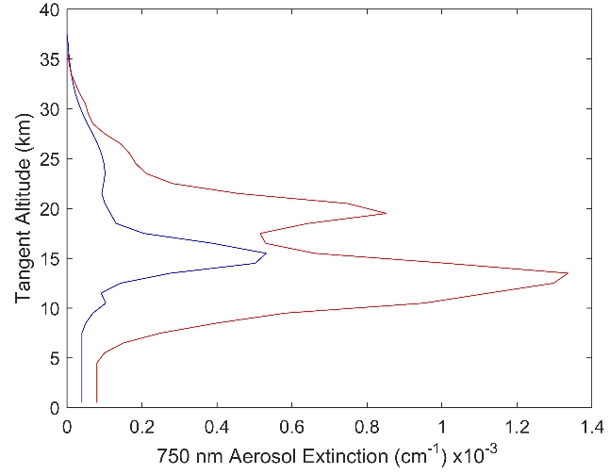

Figure 1: The two aerosol profiles used in this study. The blue is a background aerosol extinction levels, and the red curve is a representative aerosol profile after the Nabro eruption.

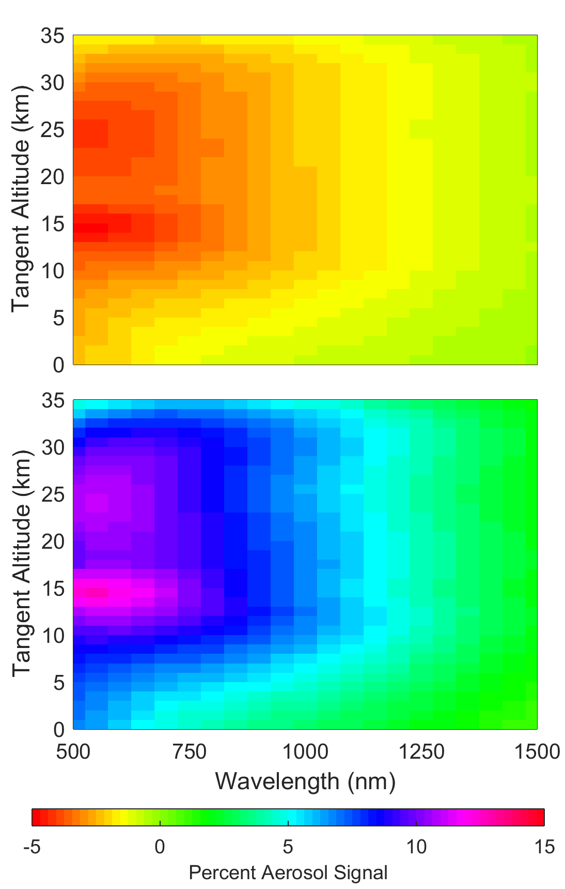

Figure 2: A computation of the percentage of aerosol signal change in the horizontal and vertical polarizations compared to the scalar. The top, and bottom figures are the horizontal, and vertical polarization respectively. The geometry for the simulation is set up with SZA of 45o and SSA of 60o with an Albedo of 0 and using the background aerosol profile.

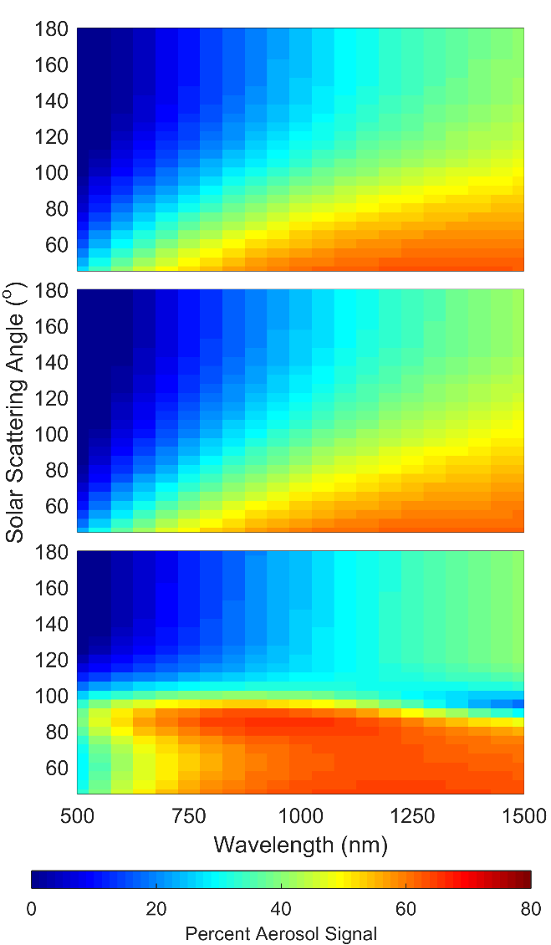

Figure 3: A computation of the percentage of aerosol signal over the total radiance for a three polarizations. The top, middle, and bottom figures are the scalar, horizontal, and vertical polarization respectively. The geometry for the simulation is set up with SZA of 45o and at an altitude 15.5 km with an Albedo of 0 and using the background aerosol profile.

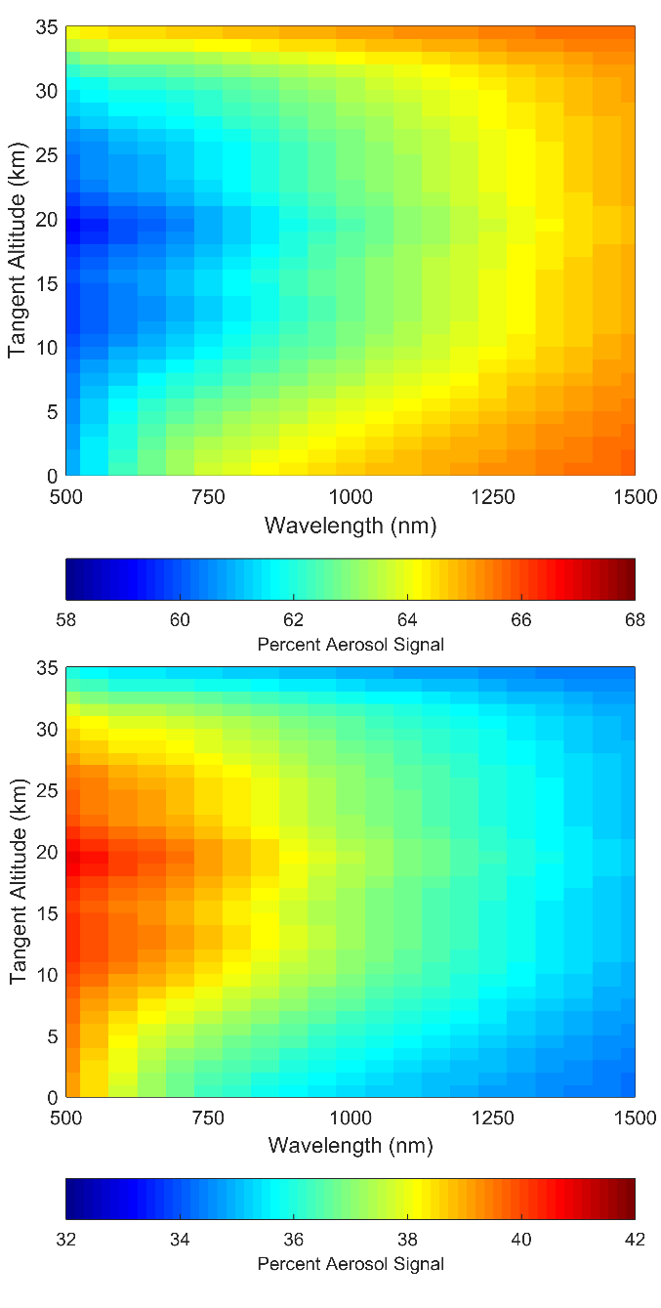

Figure 4: A percent of the linear polarized radiances over the scalar radiance, the top and bottom figures are the horizontal and vertical polarizations respectively. The radiances were calculated with a geometry of 60o SZA and 45o SSA with an albedo of 0 and using the background aerosol profile. Note that the scale for each plot are different.

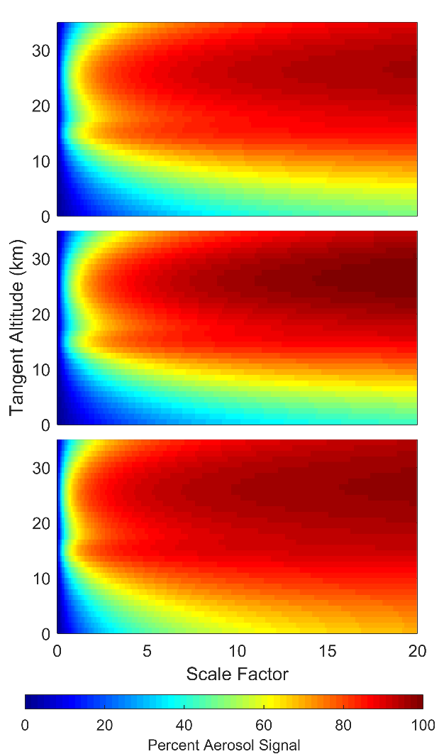

Figure 5: Similar to Figure 2 except only 750 nm wavelength is observed and the aerosol concentration has been scaled to determine where the signal saturated with aerosol.

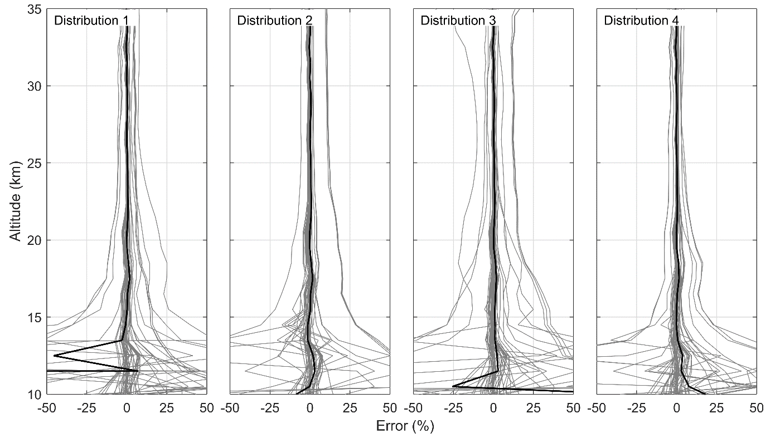

Figure 6: Percent differences of the retrieved aerosol profiles for the scalar retrieval versus the vector retrieval. Each column represents a different particle size distribution and the labels can be cross referenced in Table 1.

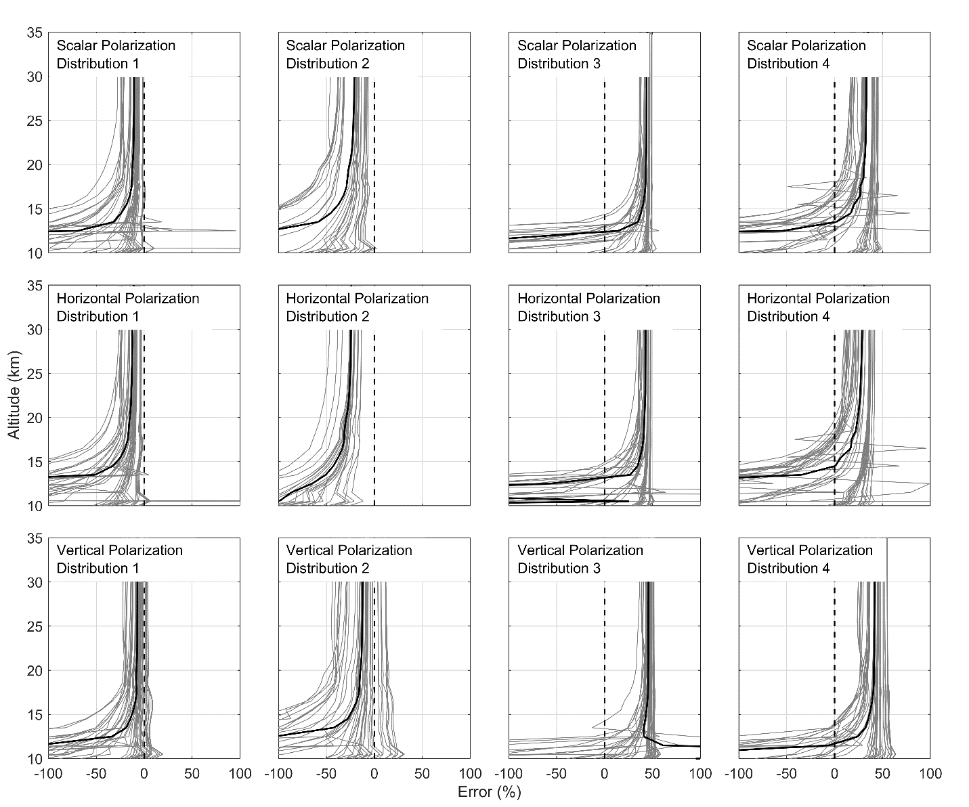

Figure 7: The retrieved aerosol profiles for each unique combination of geometry and aerosol profile are compared again the known original states. The plots are separated into 12 cases. The four columns represent the four particle size distributions used for the analysis as listed in Table 1. From the top to bottom row are the scalar, horizontal, and the vertical polarization.